Visualization 1:

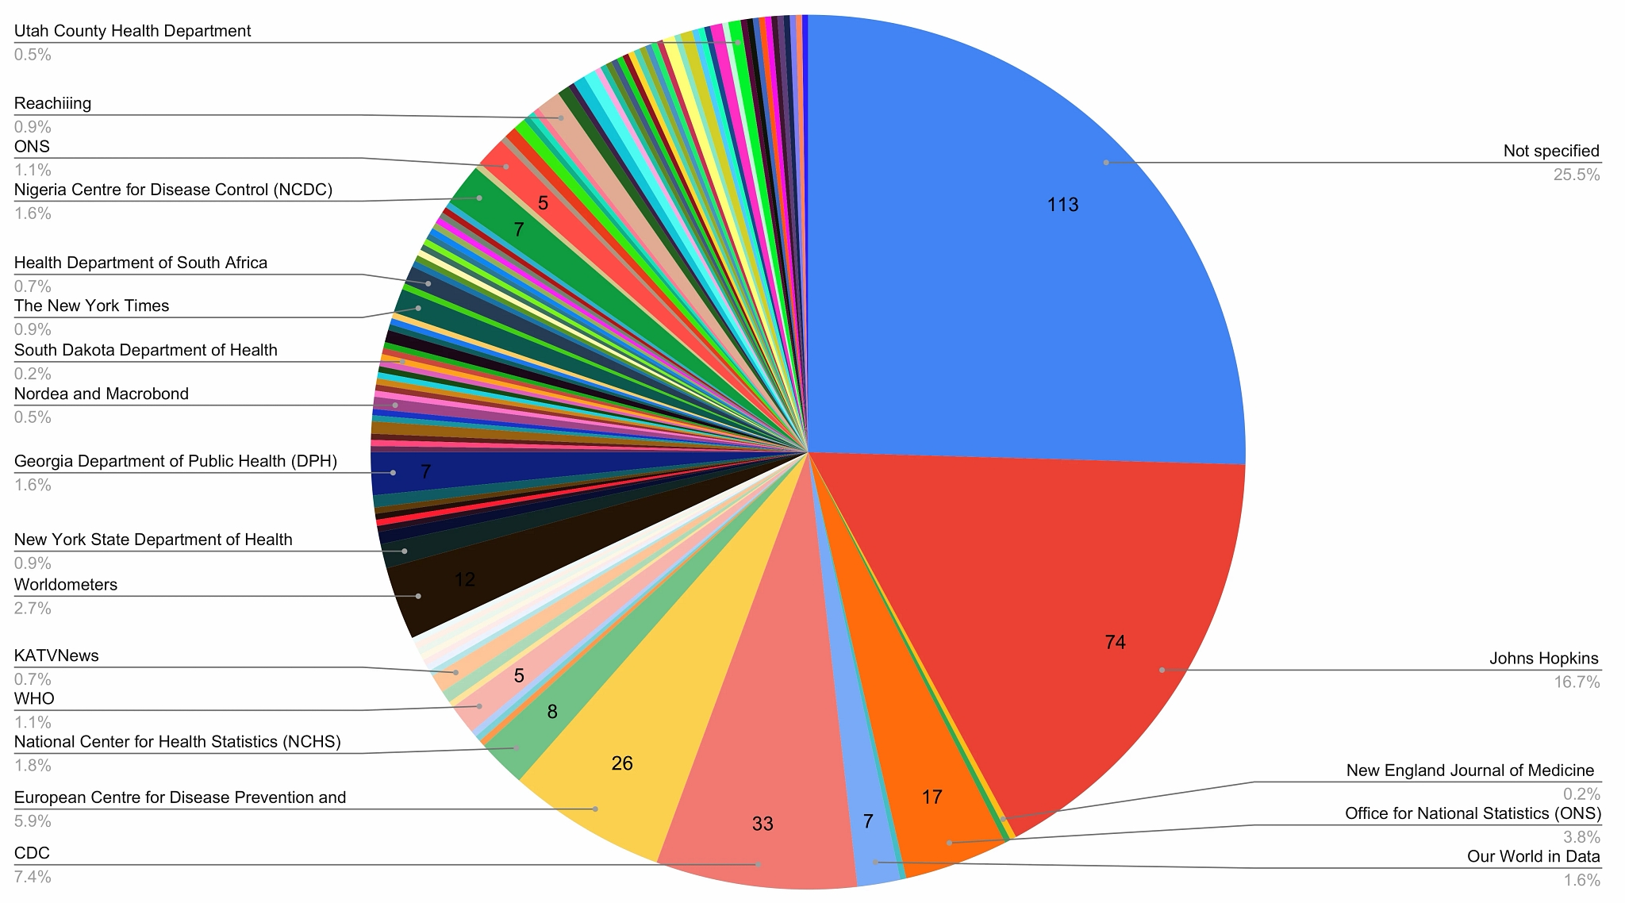

This is a pie chart showing the number of times the entity was cited for covid-19 visualization on twitter. The question itself it a good question. It shows which data sources are the most widely used. However one major problem is that one fourth of the sources are not specified. When looking at the pie chart and seeing that, I would immediately disregard the chart because such a high percentage of sources are not specified.

This type of chart (pie chart) itself is ineffective. Other than not specified and Johns Hopkins, it is hard to tell exactly the percentage of the pie chart each category occupies along with the number of times citied. A sideways bar chart would be a much better representation of this data as it would allow the viewer to more easily compare each source side by side.

As far as design elements, the chart is okay. There is a good balance of white space and the words themselves are easy to read. The downside is we are not given the amount of times less-used sources’ are accessed for a twitter post.

Source: <https://www.mdpi.com/2227-9709/7/3/35>

Visualization 2:

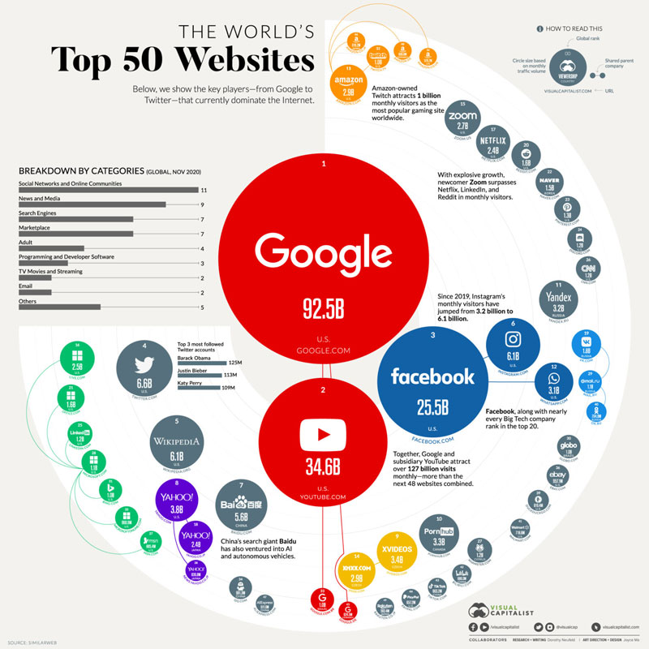

This chart is meant to convey the number of views each website has and display the ones with the most views as the largest/least as smallest bubbles. While this idea seems good in theory, the data could

Source: <https://www.visualcapitalist.com/the-50-most-visited-websites-in-the-world/>

Visualization 3:

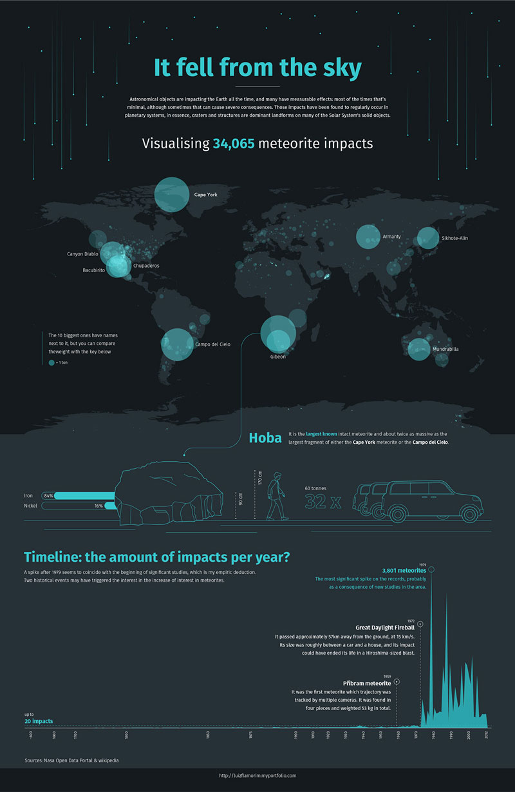

This visualization is very clean

Source: <https://www.behance.net/gallery/95352539/It-Fell-from-the-Sky>